## Week 1 Goal (according to project proposal)

“**Background reading** on image classification techniques, existing research into technical definitions of image similarity, etc. Will build up a collection of sample images for testing the algorithm on.”

## Log

I am today starting officially on the project! During semester I did a lot of preliminary work, setting up the test environment and starting on one of the trait handlers: analysis of the vertical/horizontal colour averages.

I’ve re-read the project handbook for a starting point and looked at the various links. This has got the process flowing, and I’ve written down ideas and issues to tackle in a Trello board I set up for my own convenience.

Here’s how it looks as of the end of today:

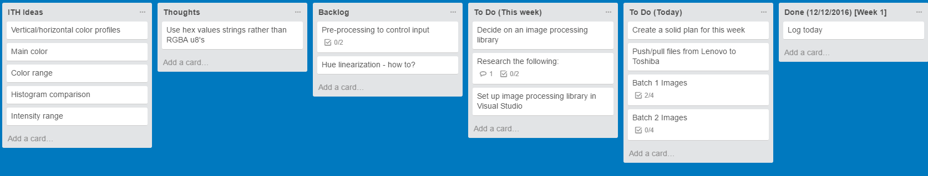

Batch 1 Test Images were transferred from phone, cropped and added to Toshiba project folder.

Went out and took a large number of photos for Batch 2 Test Images. Yet to be transferred, cropped, etc.

## Time Log

Generally speaking, the 40 credits should amount to 400 hours of work.

* Inspection week is after 3 weeks’ worth of work
* 10 logs across 10 weeks suggests 40 hours per week
* That means 160 hours per month
* 8 hours per working day (across five days)
* If I do 9-5 with 1h lunch for 3 days per week over Christmas, I’ll get 21h per week, for 84h total – half of the monthly rate.
* I would say I’ve already committed 10 hours to the project during preliminary work.
* Therefore after Christmas 95h will be completed, requiring 300h over the remaining 6 weeks. Or, 50h per week.

Today has been **afternoon only** due to morning arrangements. I plan to work three to four days per week on the project over Christmas break.

Start: 14:00  
End: 16:40